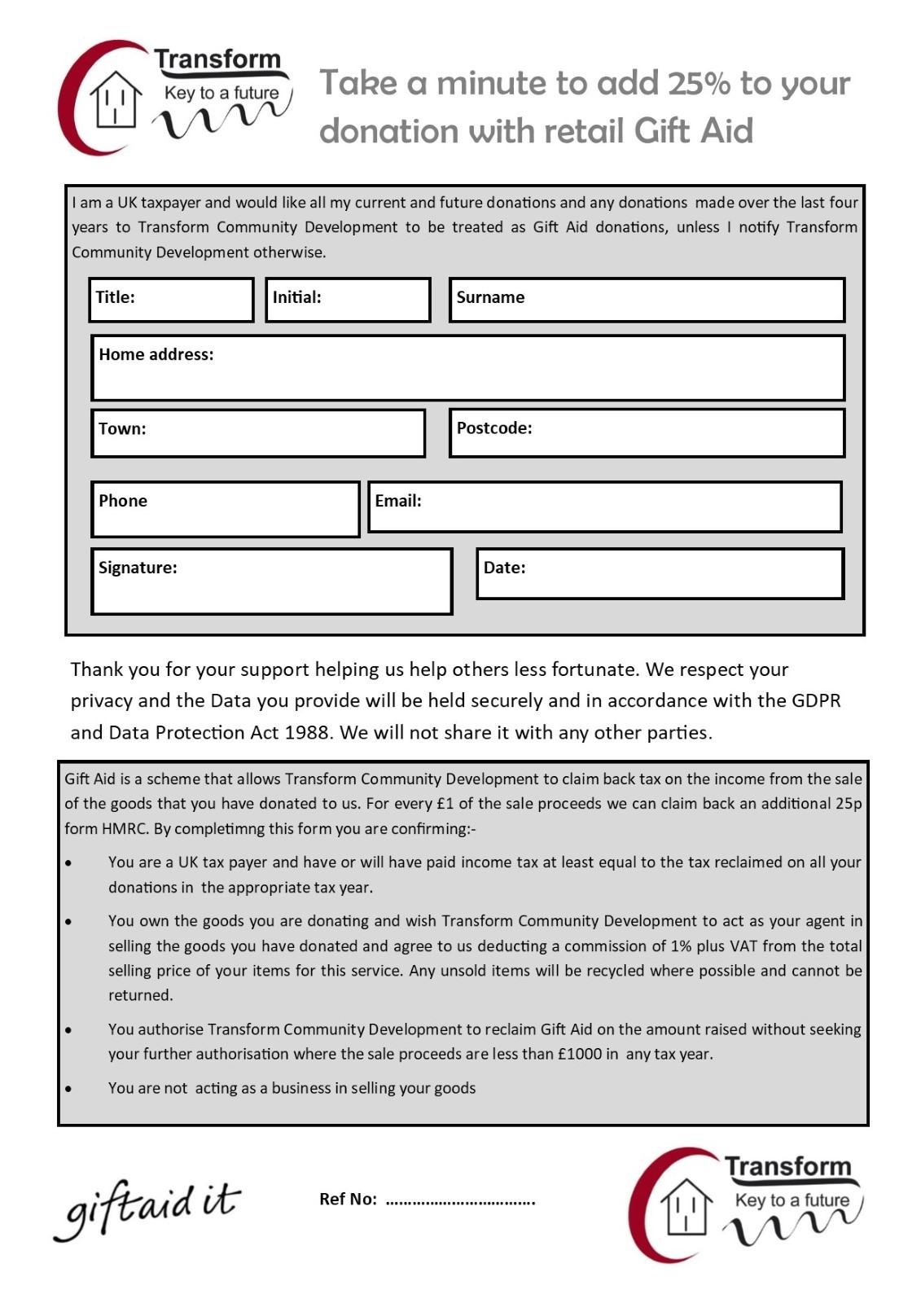

**Take a minute to add 25% to your donation with retail Gift Aid**